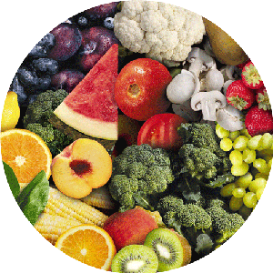Dear Parents/Guardians,

For the next week, your child will be learning about healthy eating choices and how to take care of their teeth in a Dental and Nutrition unit. Throughout the unit, your child will be able to explore several of the dental tools used at the dentist office as well as why the dentist is an important community helper. Your child will engage in many dental activities such as teeth brushing and flossing in the classroom.

As another part of our unit, we will be learning about healthy food choices. We will be sorting healthy vs. unhealthy foods as well as learning about each of the five healthy food groups. Your child will learn about eating from each of the five healthy food groups with a dinosaur puppet friend. I encourage you to ask your child what foods “Dino” liked to eat.

You are welcome to join us for any of our dental and nutrition activities. Please let me know if you interested, so we can set up a time for you to join in our Being Healthy week. It is an important life skill for your child to acquire as it will promote healthy choices. I also encourage you to talk to your child about visiting the dentist and eating healthy foods at home.

If you have any questions, please feel free to contact me through email or phone.

Thank you. I forward to working with your child in this important and exciting topic!

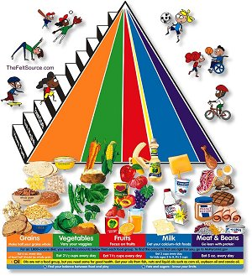

Sincerely,

Ms. Lauren Schroder